LESSON NOTES FOR LEARNING
AREA 5 LANGUAGE
DEVELOPMENT II READING

LESSON NOTES FOR LEARNING AREA 5 LANGUAGE DEVELOPMENT II READING
FOR MIDDLE CLASS
TERM I.
WEEK I
TOPIC:Learning sounds
Evaluation activity:Pupils will read out the sound loudly a, c, b, e, d, g
Learning materials: Single flash cards
TOPIC:Learning sounds
Evaluation activity:Pupils will continue reading sound loudly a, c, b, e, d, g

TOPIC:Learning sounds
Evaluation activity:Pupils will play and match sounds
“Small with big”
a B c
d E f

a b c d e f

a d f g e a d c

TOPIC: Learning sounds
Evaluation activity: Pupils will play a matching game using small and big cards
g c a

e d f

TOPIC: Learning sounds
Evaluation activity: Pupils will write sounds on slates or chalkboard on their own.

WEEK II
TOPIC: Learning sounds
Evaluation activity: Pupils will read out sounds loudly. a, c, b, e, d, g

TOPIC: Learning sounds
Evaluation activity: Pupils will copy sound “a”

a a a
- -- --
- -- --

TOPIC: Learning sounds
Evaluation activity: Pupils will copy sound “b” in books.

- b b
- - -
- - -
TOPIC: Learning sounds
Evaluation activity: Pupils will copy sound “c” in books.

- c c
- - -
- - -

TOPIC: Learning sounds
Evaluation activity: Pupils will copy sound “d”

- d d
- - -
- - -
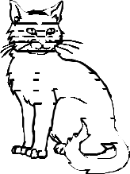
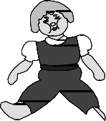

WEEK III
TOPIC: Learning sounds
Evaluation activity: Pupils will copy sound “e”
- e e
- - -
- - -

TOPIC:Learning sounds
Evaluation activity:Pupils will copy sound “f”

- f f
- - -
- - -

TOPIC:Learning sounds

Evaluation activity:Pupils will copy sound “g”
- g g
- - -
- - -
TOPIC:Learning sounds
Evaluation activity:Pupils will match the same and draw

a c

e a

- e

- b
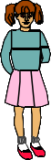


TOPIC:Learning sounds
Evaluation activity:Pupils will match the same and draw f a

d f

g d

a g

WEEK IV
TOPIC:Learning sounds
Evaluation activity:Learners will recognize and circle correct sounds e.g

TOPIC:Learning sounds
Evaluation activity:Learners will recognize and circle correct sounds e.g


TOPIC: Learning sounds
Evaluation activity: Learners will circle the given sound.
 |  |  | d | z z d


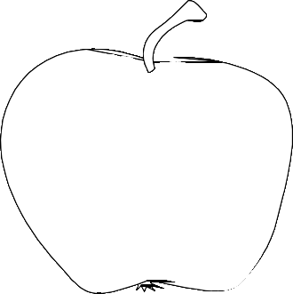


 |  |  | e |  |  | x | e | x
 |  |  | f |  |  | a | a | f
 |  |  | c |  |  | s | c | s
TOPIC: Learning sounds
Evaluation activity: Learners will circle the correct sound for the picture.
E.g.
 |  |  |  |  | b c | d
 |  |  |  |  | t a | e
TOPIC: Learning sounds
Evaluation activity: Learners will circle the correct sound for the picture.
 |  |  | 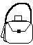 | f | a b
 |  |  |  | e | v g



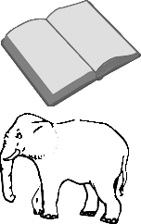WEEK V
TOPIC: Sounds
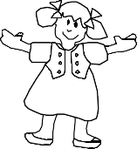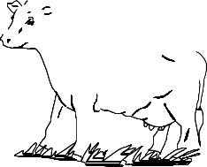Evaluation activity:Learners will color for the given sound e.g.
B =
C = | 

TOPIC: Sounds
Evaluation activity: Learners will ring the sound and color the picture.


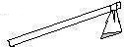 | s j a
 | d m o
TOPIC:Sounds
Evaluation activity:Learners will match sounds to pictures e.g. b

e d

TOPIC:Sounds
Evaluation activity:Learners will match more sounds to pictures. g

e

c

WEEK VI
TOPIC:Sounds
Evaluation activity: Learners will draw pictures for the given sound. b =
h = e =
TOPIC: Sounds
Evaluation activity:Learners will draw pictures for the given sound. f =
d =
a =
TOPIC:Sounds
Evaluation activity:Learners will cross the different sound. b d b b
c a c c
e i e e
WEEK VII
TOPIC:Sounds
Evaluation activity: Learners will write sound for the given picture.
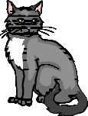
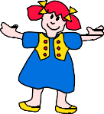


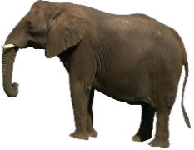
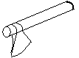
TOPIC:Sounds
Evaluation activity: Learners will tick the correct sound for the picture. p c r

b f h

e c o
WEEK VII
TOPIC:Sounds
Activity:Learners will listen and write sounds. E.g. c ------ ------

Learners will listen and write words e.g. box

_____

TOPIC:Sounds
Activity:Learners will fill in the given sound “a”
b t b g c t t p p n Learners will read and draw good pictures.
bag fan
cat box
TOPIC:Sounds
Activity:Learners will fill in the missing sounds.
p t s m b g m n
WEEK IX
TOPIC:Sounds
Activity:Learners will name the given objects

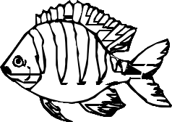



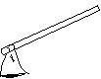

Pencil | Tin | Fish | Pot | flo  wer | ma  t | axe

TOPIC:Sounds
Activity:Learners will read and draw good pictures.
tin cup pot tree box bed book man

WEEK X
TOPIC: Sounds
Activity: learners will continue to read sounds h, j, k, m, g
TOPIC: Sounds
Activity: learners will continue to read sound “h” and write words with sound “h”
h h h h
hut hat house house

Topic: Sounds
Activity: learners will read sounds and write words of the given sounds. j j j j
jug jug jacket jacket

k k k k
kite kite kettle kettle

m m m m
man man moon moon
man man moon moon

